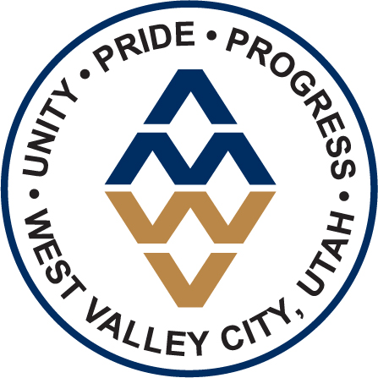
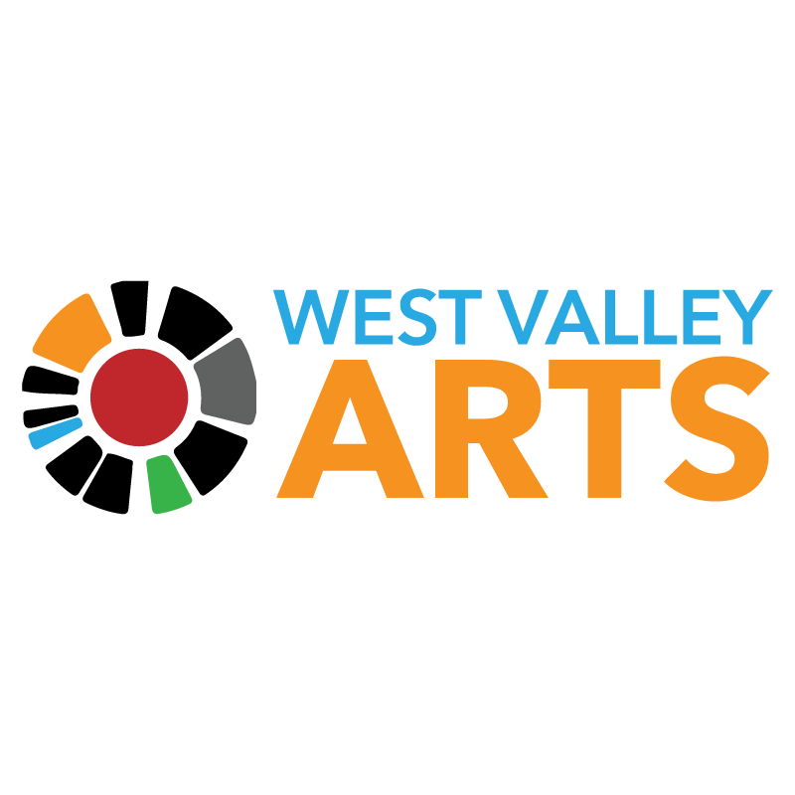

For Immediate Release:

January 27, 2021

For More Information, Contact:
Laurel Christiansen, Marketing & Communications Coordinator
(801) 965-5105
Sam Johnson, Director of Strategic Communications
(801) 965-7090

West Valley Arts 2022 Season Opens with
Family Favorite Musical Disney’s Beauty and The Beast

(SALT LAKE CITY, Utah) – Live theatre returns to Decker Lake Drive as the 2022 season kicks off with West Valley Arts production of Disney’s Beauty and the Beast from Jan. 20 to Feb. 12 at the West Valley Performing Arts Center. This family-friendly musical brings the classic French fairytale to life in an enchanting theatrical experience for all ages.

Filled with all the iconic characters, soaring melodies, and infectious dance numbers audiences adore, seats will sell fast for this dose of fantasy. The original Broadway production of Beauty and the Beast earned nine Tony Award® nominations, including Best Musical. Featuring the timeless songs of Alan Menkin, Howard Ashman, and Tim Rice, West Valley Arts production of Disney’s Beauty and the Beast is a warm, fun thing-to-do this winter.

“This musical is a crowd favorite, offering excitement and fantasy for all ages,” said Jeff Olson, Manager of the West Valley City Division of Arts and Culture, “We cannot wait for your family to stop by and enjoy this production.”

West Valley Arts provides the community with year-round access to live theatre in West Valley City. Shows are produced using local talent and are a great way to experience the joy of live theatre with the entire family.

Individual Ticket Prices are $25 for adults and $18 for youth ages 5-12 and are available online at www.wvcarts.org or by calling the box office at (801) 965-5140

West Valley Arts - The West Valley Arts and Cultural Foundation is a 501c3 nonprofit arts organization that works in conjunction with the West Valley City Division of Arts and Culture to provide a variety of arts programming for residents of West Valley City and the Wasatch Front. West Valley Arts’ mission is to create opportunities to learn, experience and celebrate art, culture and community.

###

