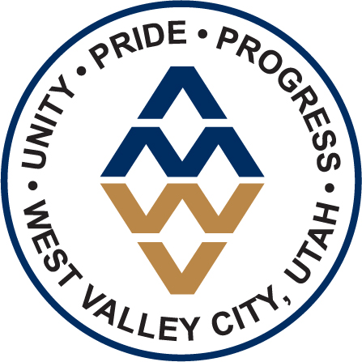
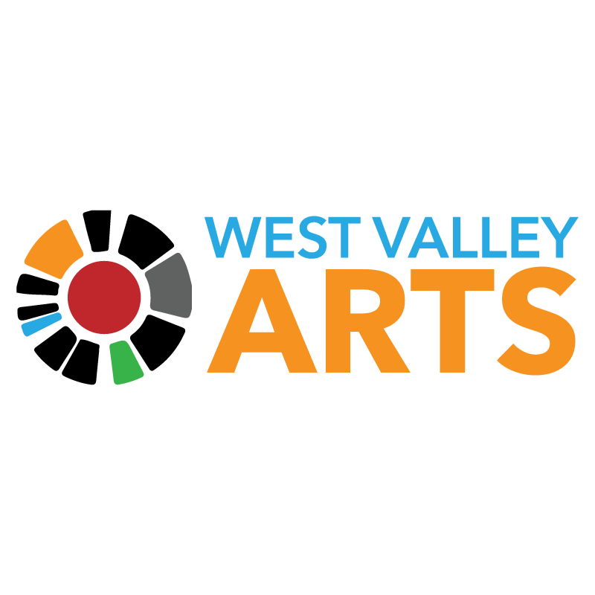

For Immediate Release:
June 23, 2022

For More Information, Contact:
Laurel Christiansen, Marketing & Communications Coordinator
(801) 965-5105
Sam Johnson, Director of Strategic Communications
(801) 965-7090

West Valley Arts Production of “In the Heights”
Is a Timely Celebration of a Community’s Body and Soul
(SALT LAKE CITY, Utah) – West Valley Arts is pleased to announce its summer production of “In the Heights” from June 23 – July 16 at the West Valley Performing Arts Center. This full-length musical brings the universal story of dreams and hope for a bright future to West Valley City.

This full-length musical tells the story of a community in New York’s Washington Heights neighborhood, where the biggest struggles can be deciding which traditions you take with you and which ones you leave behind. “In the Heights” won four Tony Awards®, including Best Musical. With music and lyrics by Lin-Manuel Miranda and book by Quiara Alegría Hudes, this show is an instant audience favorite.

Pedros Flores takes on the role of Usnavi, Micki Martinez as Vanessa, Beatrix Melo as Nina and Kiirt Banks as Benny. The cast is rounded out by Sonia Inoa-Maughan, Monte Garcia, Luseane Pasa, Teresa Jack, Scotty Fletcher, Roberto Fernandez, Eli Ghaeini, and Sophia Davis. Juan Hector Pereira directs this production of In The Heights, while choreography is by Izzy Arrieta.

This production also represents the continued strength of the relationship between West Valley Arts and the community. “We are thrilled to have cast this show fully with people of color for ‘In The Heights,” said Jeff Olsen, Division Manager of West Valley City Arts and Culture. “The talent is here in Utah and we hope the community will join us at the show.”

West Valley Arts exhibition “Fly This Flag” will open in conjunction with the show, encouraging conversation around cultural and national identity throughout the Americas. Individual Ticket Prices are $25 for adults and $18 for youth ages 5-12 and are available online at www.wvcarts.org or by calling the box office at (801) 965-5140.

West Valley Arts - The West Valley Arts and Cultural Foundation is a 501c3 nonprofit arts organization that works in conjunction with the West Valley City Division of Arts and Culture to provide a variety of arts programming for residents of West Valley City and the Wasatch Front. West Valley Arts’ mission is to create opportunities to learn, experience and celebrate art, culture and community.
###

