Rivers Instructional Case: A series of student-centered science lessons

Lesson 1

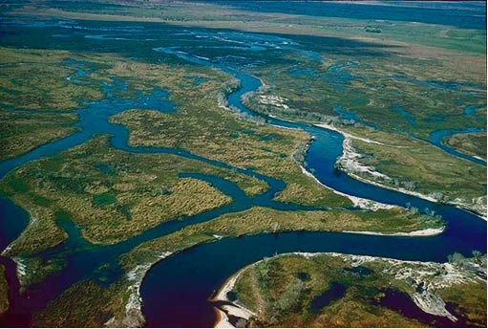
Kissimmee River Source: USGS

Suggested Timeline

30-45 minutes

Materials
- Pre-assessment Probe “Down by the River”
- Enlarged “Down by the River” Graphic
- Chart paper
- Red markers
- Chart markers

Prep
- Make duplicate copies of the pre-assessment probe for each student. One side of the probe is to be administered at the very beginning of the lesson.
- Collect probes and re-administer at the end of the lesson and notice any shifts in thinking.
- Project enlarged “Down by the River” graphic for the entire class to see.
- After lesson is done, post up questions generated from the class around the room.
Down by the River

Summary

In this lesson, the teacher administers an assessment probe to activate students’ prior knowledge about how moving water (rivers) changes the surface of the Earth. The results of this probe can be used to guide instruction to address misconceptions and gaps in understanding. Students’ responses will be given back to them to create a continuum of learning after the unit has been completely presented. The real life application of which side of the river should you build your house on stimulates students’ interest in the erosion and deposition of sediment that may modify the landscape.

Objective
- To activate student thinking on the evolution of rivers and the changing nature of the landscape.
- To generate investigable questions about the topic.
- To use prediction as a way to engage students’ thinking on river movements.

Teacher Background Knowledge
This assessment probe focuses on the constantly changing nature of rivers. Over relatively short periods of time (tens or hundreds of years), the channel of a river can change significantly. Mature rivers change through the formation of meanders. Meanders are bends or curves in a stream channel that become increasingly sinuous and curved over time. Meanders form from the deposition of sediment on the inside of the bend forming sedimentary deposits known as point bars. On the opposite side (outer portion of the bend), the bank of the river is subjected to erosion. Simultaneous deposition on the inside bank and erosion on the outside bank results in an increase in curvature of the stream channel.
In the long term, it is never a good idea to build a home adjacent to a wild river (a river lacking engineered controls) since the channel will change. In the short term, the channel of the river will generally migrate in the direction of the formation of the meander.

Standards
NGSS Performance Expectations:
This lesson supports students in progressing toward the NGSS Performance Expectation.
MS-ESS2-1. Develop a model to describe the cycling of Earth's materials and the flow of energy that drives this process. [Clarification Statement: Emphasis is on the processes of melting, crystallization, weathering, deformation, and sedimentation, which act together to form minerals and rocks through the cycling of Earth’s materials.]
Assessment Boundaries: Assessment does not include the identification and naming of minerals.
In this lesson…
Science and Engineering Practices | Disciplinary Core Ideas |  | Cross Cutting Concepts
Asking Questions and Defining Problems  Students ask questions that can be investigated within the scope of the classroom, outdoor environment, and museums and other public facilities with available resources. Students will be using the question formulation technique to generate questions about the river orientation and how this relates to the building of a new house. As students generate the questions, they will chart the questions and post them around the classroom as they go through this instructional case. | ESS2.A: Earth’s Materials and Systems  All Earth processes are the result of energy flowing and matter cycling within and among the planet’s systems. This energy is derived from the sun and Earth’s hot interior. The energy that flows and matter that cycles produce chemical and physical changes in Earth’s materials and living organisms. Students learn about erosion and how this contributes to physical changes on the Earth’s surface. Erosion may be caused by natural forces such as water, rain, waves, and other surface activities. Students are particularly looking at the landform itself and the amount of water within the system. |  | Stability and Change  Explanations of stability and change in natural or designed systems can be constructed by examining the changes over time and processes at different scales, including the atomic scale. Students investigate both natural and designed systems when placing the new house on the river property. Students analyze stability and change with respect to the river and the water cycle.
In this lesson…
CCSS Mathematics |  | CCSS English-Language Arts
N/A |  | SL.8.5 Integrate multimedia and visual displays into presentations to clarify information, strengthen claims and evidence, and add interest. Students are documenting questions and using the chart paper to display questions to the class and revise or add to questions as the lesson progresses.

Prior Knowledge
In grades 3-5, Students have learned that nearly all of the Earth’s available water is in the ocean. Most fresh water is in glaciers or underground; only a tiny fraction is in streams, lakes, wetlands and the atmosphere.

Lesson
- Distribute “Down by the River” probe to each student.
- Explain to the students that the Down by the River assessment probe is designed to see what they already know about how rivers shape the surface of the earth.
- Show the students the drawing of the river with the two houses (house A and house B) constructed on the left bank and right bank of the river. Point out that house A and house B are situated in 2 different curve orientations of the river.
- Use the “Question Formulation Technique” where students will be in groups of four and ask questions about the given image. Provide different colored markers to ensure that all students participate with their designated marker.

- PRODUCE YOUR QUESTIONS
- Four Essential Rules for Producing Your Own Questions:
    - Ask as many questions as you can
    - Do not stop to discuss, judge or answer the questions
    - Write down every question exactly as it is stated
    - Change any statement into a question
- IMPROVE YOUR QUESTIONS
- Categorize your questions as investigable or non-investigable:
  - Investigable questions meet the following criteria:
- I do not already know the answer(s) to this question.
- Question leads to a plan for what I need to do to answer the question, including the evidence I need to collect.
- This question can be answered with available material.
- This question can be answered in a reasonable amount of time.
  - Write INV next to investigable questions
  - Cross out non-investigable questions or rewrite them so they can be investigated.

- Categorize the questions as Closed- or Open-ended:
  - Closed-ended questions can be answered with “yes” or “no” or with one word.
  - Open-ended questions require an explanation and cannot be answered with “yes” or “no” or with one word.
  - Find closed-ended questions. Mark them with a “c.”
  - The other questions must be open-ended. Mark them with an “o.”
  - Discuss the value of each type of question:
  - Advantages & disadvantages of closed-ended questions
  - Advantages & disadvantages of open-ended questions
  - Change questions from one type to another:
  - Change one closed-ended question to open-ended.
  - Change one open-ended question to closed-ended.
- Have students chart questions on chart paper and mark the questions that are investigable in red marker. Post the chart papers around the room throughout the duration of this instructional case.
- Read the instructions- Brad recently bought some land to build his dream house. In the middle of the land a river ran through it. He asked a couple of friends their opinion on the placement of the house.
- Review the 3 bulleted choices available to the students to think about:
  - Dustin told Brad to build on Side B because the river would eventually move towards Side A.
  - Anthony told Brad to build on Side A because the river would move towards Side B.
  - Grant thought either side was good because the river won’t ever change direction.
- Modifications for English Learners: Point to the houses on each side of the river and ask where they would build a house.
- Students work individually on this assessment. Teacher may read the prompt, show the drawing on the board and restate the choices available to students.
- Encourage students to give a well- thought of and logical explanation for their choice.
- Collect the assessment probes and:
  - Tally the students’ responses to Side A, B or neither.
  - Analyze the students’ explanations and note down misconceptions.
  - Analyze the vocabulary used in their explanations.
- Keep this probe to use as a post assessment.

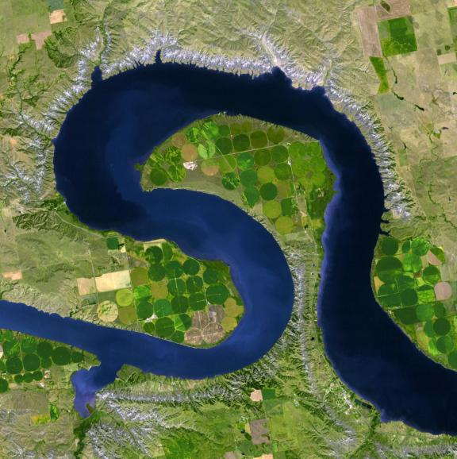
Potential Pitfalls
Lake Sharp Source: NASA
The expected answer that would manifest satisfactory reasoning is the selection of Side B- 1st bullet (Dustin’s suggestion to Brad). Most students, based on experience and/or perceived logical direction of the force of water, reasoned out that “the force of water will push outward”. Some reasoned that “flooding may occur on Side A because water will overflow in that direction”. Yet other students will instinctively know the direction of the water but could not use the correct vocabulary to explain the prediction.

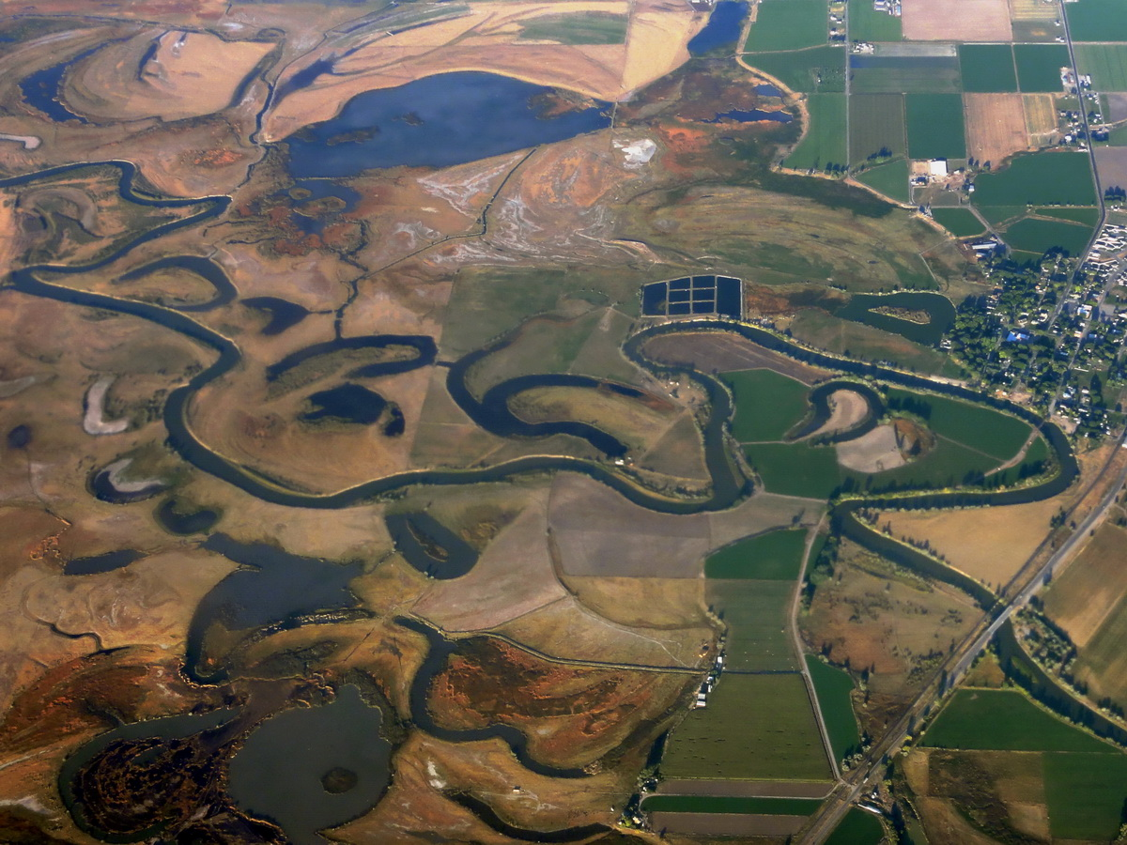
A few students gave Side A as the “safer” house due to misconceptions and an off tangent explanation for the river movement. The most believable and logically sound misconception was “…the river is going to cut-off a part to make an oxbow lake, and the course of the river will go towards Side B”. This may occur if the speed and/or the volume of water moving through the river increases, therefore causing the bends in the inner bank to break to form an oxbow lake on the outer bend. Without that detail the natural course of the river is to widen on the outer bend. Other students mentioned deposition in the inner bend but thought it “bad for Side B house”. Other responses included “wind”, “fish”, “fish food”, all of which have no effect on the surface changes that are expected.
Bear River Source: NASA
Another reasonable response to this prompt is “neither side is safe”. The acceptable explanation would be that the movement of the river is, to a certain degree, unpredictable, and therefore building a house anywhere near a river may prove to be disastrous.

NGSS Lead States. 2013. Next Generation Science Standards: For States, By States. Washington, D.C.: The National Academies Press.
National Governors Association Center for Best Practices, Council of Chief State School Officers Title: Common Core State Standards (insert specific content area if you are using only one) Publisher: National Governors Association Center for Best Practices, Council of Chief State School Officers, Washington D.C. Copyright Date: 2010
Adapted from materials provided by the Right Question Institute, Harvard University http://rightquestion.org/ ©2012 The Right Question Institute with supplemental information from: Sharkawy, A. (2010). A Quest to Improve: Helping students learn how to pose investigable questions. Science & Children, 48(4), 32-35

